**IV. Entities**

1. **University :**

* List of departments
* View & Update functions accessed only by Faculty
* On view of each department, one can see the courses offered by this department
* Final Performance metrics is calculated by considering the weightage of each factor

1. Student Feedback - On Course, faculty
2. Jobs bagged by the students in the current semester/year
3. General feedback - By Alumni and Employers on respective Department
4. **Student :**

* Class selection - list of classes available for students based on the semester
* Course Enroll - list of courses, type of course(online or in-person), their respective teaching faculty and feedback rating for the same
* Grades - Final GPA, Class schedule
* Feedback to Course and Faculty
* Co-op feedback
* Scholarship

1. **Faculty :**

* View & Update Faculty profile
* View & Update Course syllabus
* View current teaching courses
* View enrolled Students list
* Class schedule for each Faculty

1. **Department :**

* List of Degrees
* Each degree has a list of offered courses
* Rating of department based on feedback by students’ and employers’ rating
* List of companies associated with the department - Employer Directory
* Mandatory course enforced by individual department
* Scholarship programs

1. **Employer :**

* Linked to Department based on different job roles available for the students to apply
* Availability of job role
* Requirements for applying for the job
* Student’s possible Date of joining
* Provides feedback on syllabus, co-op student and employed students from the same university for over 5 years

1. **Courses :**

* Different of courses offered during the particular semester and course timing, teaching faculty, Name, credit hours, seats, minimum/max credits allowed per sem

1. **Domain :**

(e.g Data scientist, software engineer roles)

To track the connection of courses and their relevance to graduates'

growth.

* List of courses
* Student’s preferred Domain name
* Course wise priority
* Number of students who got jobs in a specific domain

1. **Feedback**:

This entity stores the feedback for different Courses and Faculty. This is used to calculate the total rating.

1. **Job Portal**:

This dashboard displays different jobs available, from which students can view listings and apply from this portal. It updates the results of students who have got the job through the portal. This portal informs respective departments about the count of students who bagged jobs in various timelines.

1. **Alumni**:

Alumni profiles are stored in this entity. Alumni can login to the system and update their current data related to their job profile, company they’re working for presently and other achievements.

1. **Curriculum**:

Stores the list of Courses under a specific department based on the specialisation opted by the student.

1. **Academic**:

This entity stores the academic information of students based on different courses opted by them. Here, transcripts are included to calculate the total GPA of each Student.

**Sequence Diagram-**

**Jobs bagged by the students**

Please refer Figure 2

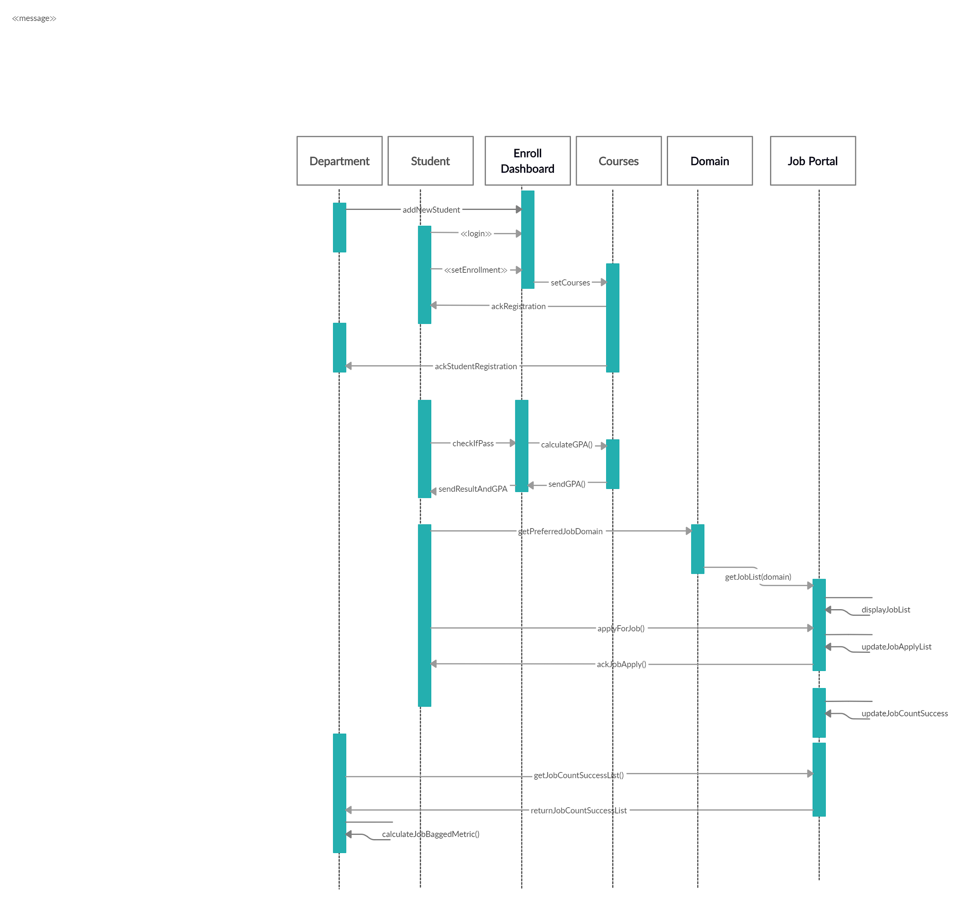

Figure 2- Sequence diagram for metric - job bagged by students

**VIII. Dashboard Design (UI Basic Design)**

**Main page :**

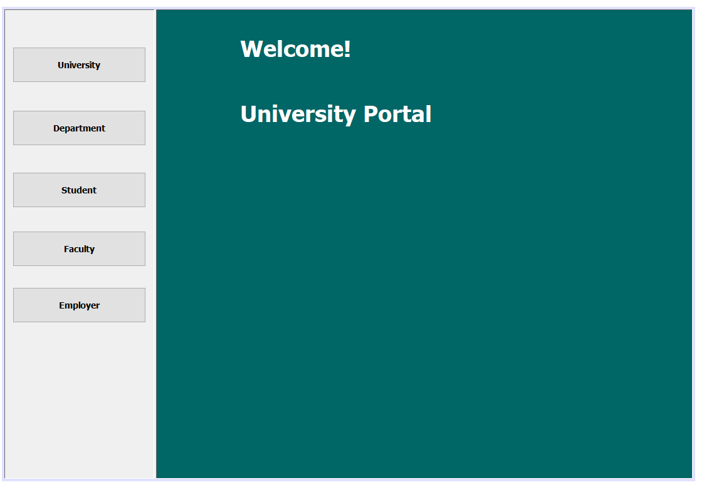

**University Dashboard :**

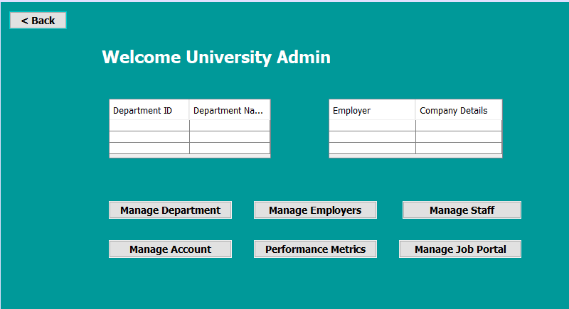

**Department Dashboard :**

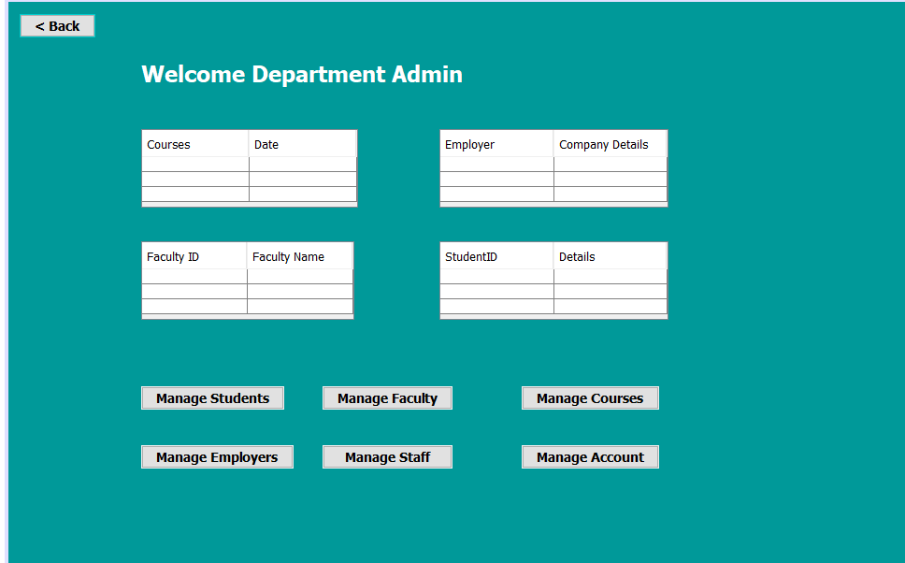

**Profile Creation :**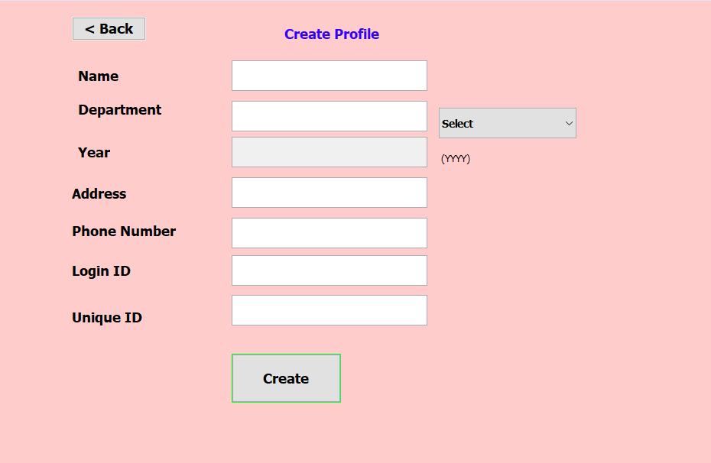

**Manage Profile :**

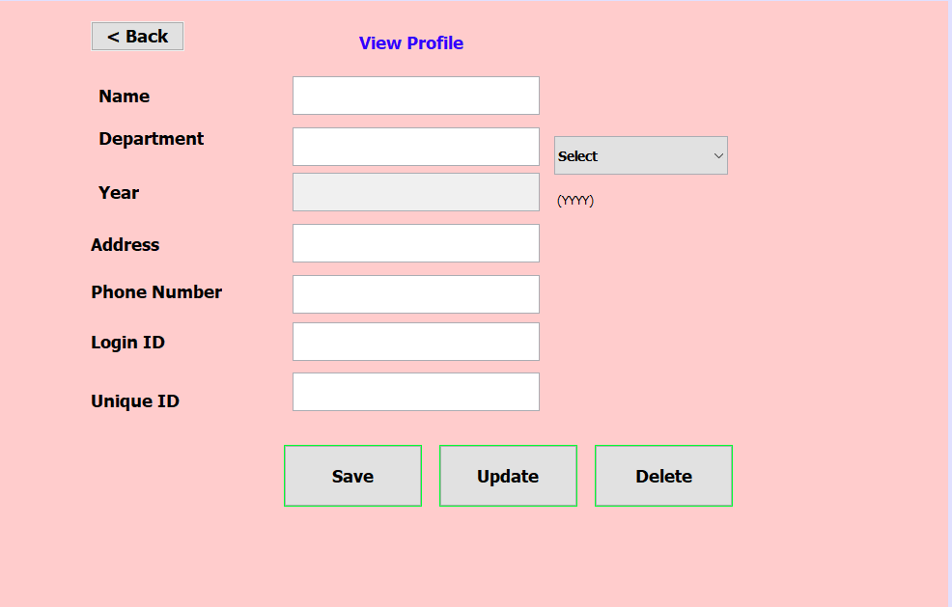

**Professor Dashboard :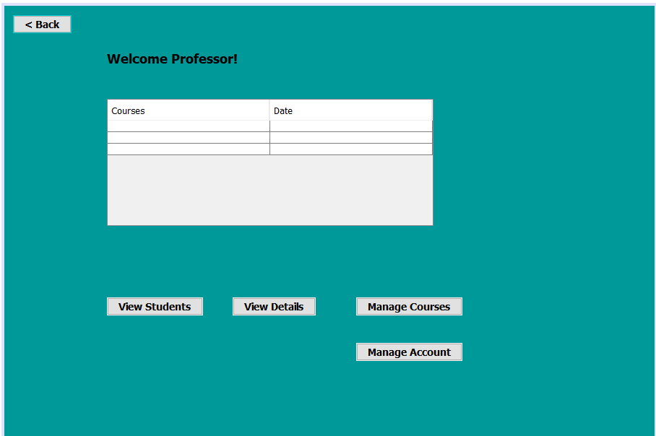Student Dashboard :**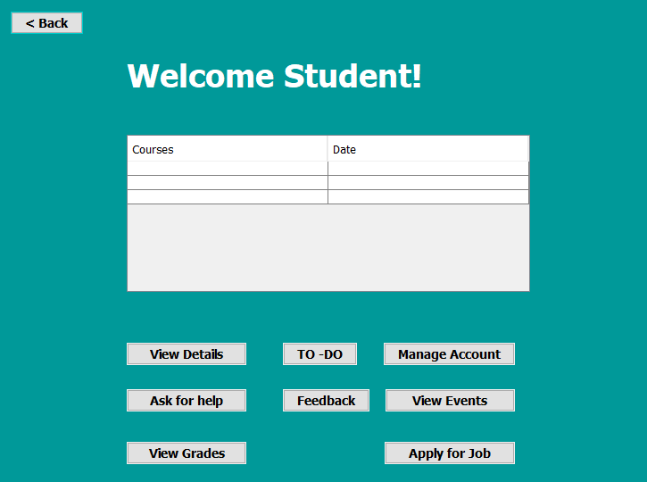

**Feedback :**

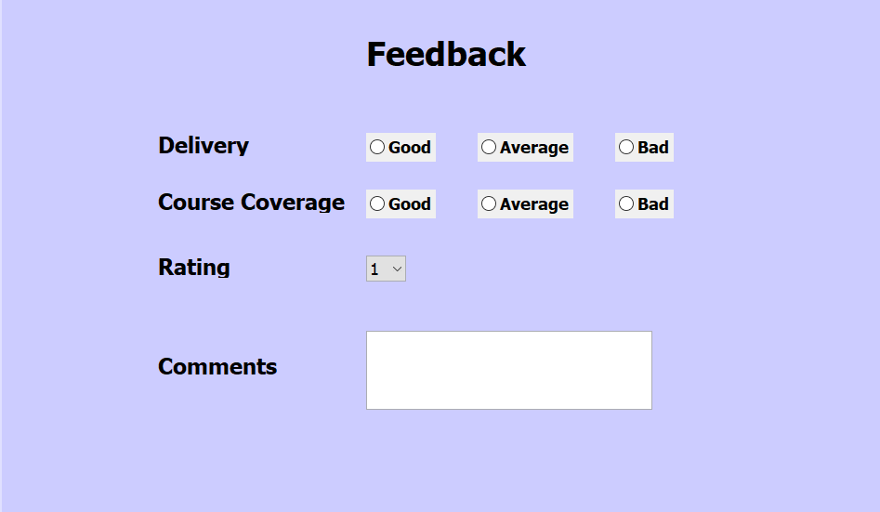

**Job Portal :**

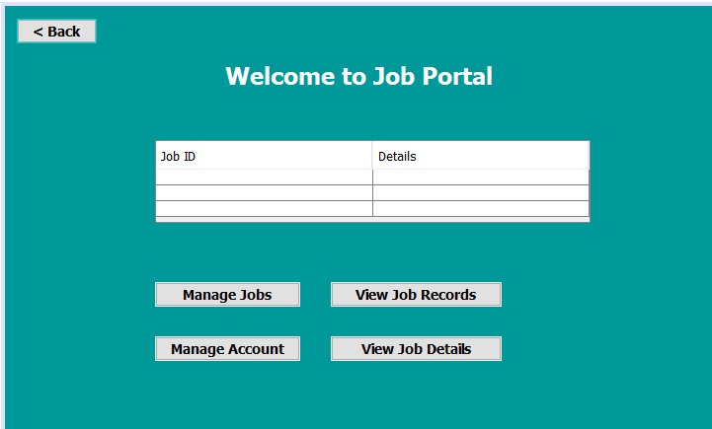

**Employer Dashboard :**

